***Experiment 5***

***Code for 8 Puzzle using uninformed search:***

import sys

import numpy as np

class Node:

def __init__(self, state, parent, action):

self.state = state

self.parent = parent

self.action = action

class StackFrontier:

def __init__(self):

self.frontier = []

def add(self, node):

self.frontier.append(node)

def contains_state(self, state):

return any((node.state[0] == state[0]).all() for node in self.frontier)

def empty(self):

return len(self.frontier) == 0

def remove(self):

if self.empty():

raise Exception("Empty Frontier")

else:

node = self.frontier[-1]

self.frontier = self.frontier[:-1]

return node

class QueueFrontier(StackFrontier):

def remove(self):

if self.empty():

raise Exception("Empty Frontier")

else:

node = self.frontier[0]

self.frontier = self.frontier[1:]

return node

class Puzzle:

def __init__(self, start, startIndex, goal, goalIndex):

self.start = [start, startIndex]

self.goal = [goal, goalIndex]

self.solution = None

def neighbors(self, state):

mat, (row, col) = state

results = []

if row > 0:

mat1 = np.copy(mat)

mat1[row][col] = mat1[row - 1][col]

mat1[row - 1][col] = 0

results.append(('up', [mat1, (row - 1, col)]))

if col > 0:

mat1 = np.copy(mat)

mat1[row][col] = mat1[row][col - 1]

mat1[row][col - 1] = 0

results.append(('left', [mat1, (row, col - 1)]))

if row < 2:

mat1 = np.copy(mat)

mat1[row][col] = mat1[row + 1][col]

mat1[row + 1][col] = 0

results.append(('down', [mat1, (row + 1, col)]))

if col < 2:

mat1 = np.copy(mat)

mat1[row][col] = mat1[row][col + 1]

mat1[row][col + 1] = 0

results.append(('right', [mat1, (row, col + 1)]))

return results

def print(self):

solution = self.solution if self.solution is not None else None

print("Start State:\n", self.start[0], "\n")

print("Goal State:\n", self.goal[0], "\n")

print("\nStates Explored: ", self.num_explored, "\n")

print("Solution:\n ")

for action, cell in zip(solution[0], solution[1]):

print("action: ", action, "\n", cell[0], "\n")

print("Goal Reached!!")

def does_not_contain_state(self, state):

for st in self.explored:

if (st[0] == state[0]).all():

return False

return True

def solve(self):

self.num_explored = 0

start = Node(state=self.start, parent=None, action=None)

frontier = QueueFrontier()

frontier.add(start)

self.explored = []

while True:

if frontier.empty():

raise Exception("No solution")

node = frontier.remove()

self.num_explored += 1

if (node.state[0] == self.goal[0]).all():

actions = []

cells = []

while node.parent is not None:

actions.append(node.action)

cells.append(node.state)

node = node.parent

actions.reverse()

cells.reverse()

self.solution = (actions, cells)

return

self.explored.append(node.state)

for action, state in self.neighbors(node.state):

if not frontier.contains_state(state) and self.does_not_contain_state(state):

child = Node(state=state, parent=node, action=action)

frontier.add(child)

start = np.array([[1, 2, 3], [8, 0, 4], [7, 6, 5]])

goal = np.array([[2, 8, 1], [0, 4, 3], [7, 6, 5]])

startIndex = (1, 1)

goalIndex = (1, 0)

p = Puzzle(start, startIndex, goal, goalIndex)

p.solve()

p.print()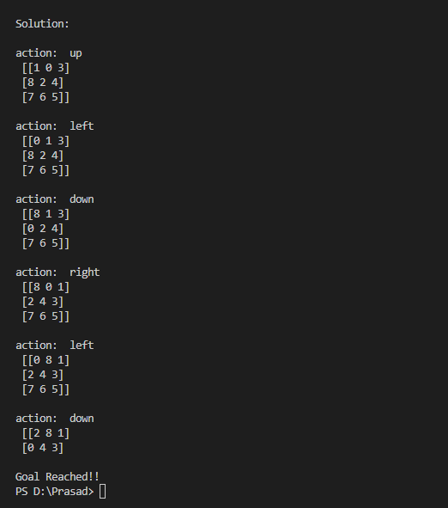

***Output:***